**A very simple flow to with Git.**

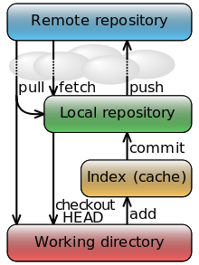

Simple ways to use GitBash (the line command application)

1. Basic Commands:
   1. ls: list files in the current directory.
   2. Change current directory? Right click on GitBash: right click on Git Bash, change initial path.
   3. git status: status of files.
   4. git log: commit history.
   5. git diff: differences in tracked files.
   6. git diff --cached: differences in staging area (cached)
   7. git rm --cached <file>: remove from staging area (cached)
   8. shift zz : exit log when it is too big.
   9. git commit -a -m “message”: add all changes to the staging area.
   10. git log -oneline: each commit in a one line message.
   11. git status -s: shortcut status
2. Simple steps and commands when working from the working directory to the local repository.
   1. git init <project>: project is now the repository (or new project).
   2. git add . : add all the files in the repository to staging area (cache). **This clears once you commit.** You need to add is you want to commit again.
   3. git commit –m “message”: make a snapshot at that moment of all the files that changed.
3. Simple step to work in a remote repository:
   1. I’m working on this.